**Netaji Subhas University of Technology**

# 

**Fourth Semester**

**ICE-1**

**Batch 2022-26**

# **Engineering Analysis and Design**

**(**ICICC10**)**

**ECG Signal Enhancement**

| Submitted To: Mrs.Anuradha Tomar |  |  | Submitted By: Krish Gupta 2022UIC3507  Devansh Behl 2022UIC3582  Meet Singh 2022UIC8057 |
| --- | --- | --- | --- |

**Aim**

Transforming Raw Data to Enhanced Filtering for Accurate Interpretation

**Software/Hardware Used**

Dell Latitude 5420, MATLAB (version R2023b), Simulink Toolbox (version 11.1)

**Brief Summary**

The project focuses on improving the quality and accuracy of electrocardiogram (ECG) signals through signal refinement techniques. Traditionally, ECG signals are prone to noise and interference, which can affect the interpretation and diagnosis of cardiac conditions. By developing advanced filtering algorithms, the project aims to convert unfiltered ECG signals into filtered ones, resulting in enhanced clarity and reliability for medical analysis. The refined signals will provide clinicians with more accurate insights into cardiac activity, facilitating better diagnosis and treatment decisions

**Objectives**

1. To preprocess raw ECG data and remove noise and artifacts using digital filtering techniques.
2. To implement advanced filtering algorithms for baseline wander removal and powerline interference suppression.
3. To enhance the quality of ECG signals while preserving important features for accurate interpretation.
4. To validate the effectiveness of the proposed filtering approach through quantitative analysis and comparison with existing methods.

**Theory**

1. Bioelectric signals are specific types of biomedical signals that are obtained by electrodes that record the variations in electrical potential generated by physiological processes.
2. The human body is made up of several systems. Each of these systems is made up of several subsystems that carry on many physiological processes. Each physiological process is associated with certain types of

signals that reflect their nature and activities. These signals are referred to as biomedical signals.

Example:

**Heart problem** – changes in electrocardiogram (ECG) or changes in blood pressure.

**Neurological disorders (such as epilepsy)**-changes in electroencephalogram (EEG).

1. The AP (Action Potential) is the electrical signal that is generated by a single cell when it is mechanically, electrically, or chemically stimulated.

1. It is the primary mechanism through which electrical signals propagate between cells, tissues, and organs.

2. It is due in part, to an electrochemical imbalance across the cell membrane, and in part, due to the selective permeability of the membrane to certain ion.

**Electromyogram (EMG):**

The EMG is the graphic representation of the electrical activity of the electrical activity of the muscle cells.It is the integration of millions of muscle APs as measured from the skin surface.EMG is a surface signal obtained through surface and/or needle electrodes.

Usually, muscle electrical activity is recorded by placing electrodes near the muscle of interest as shown in the following figure.

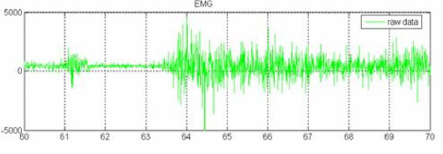

**(Fig-1.1-Example of EMG Signal )**

**ECG:**

ECG is the graphical recording of the electrical activity of the heart.It is the combination of many APs from different regions of the heart that makes up the ECG. Electrocardiogram (ECG) signals are vital in diagnosing various heart-related disorders. However, raw ECG signals are often contaminated with noise, artifacts, and baseline wander, which can obscure important features and lead to misinterpretation. Therefore, effective filtering techniques are essential to enhance the quality of ECG signals for accurate interpretation.

An electrocardiogram (ECG) is a crucial diagnostic tool used to evaluate the electrical activity of the heart. It records the heart's rhythm and electrical impulses, providing valuable insights into cardiac health. During an ECG, electrodes are placed on the chest, arms, and legs, which detect the electrical signals generated by the heart as it beats. These signals are then displayed graphically on paper or digitally on a monitor.

By analyzing the ECG waveform, healthcare professionals can identify various cardiac conditions such as arrhythmias, heart attacks, and abnormalities in the heart's structure. ECGs are often performed during routine check-ups, before surgery, or in emergencies to assess cardiac function quickly and accurately. Due to its non-invasive nature and ability to provide immediate results, the ECG is an indispensable tool in cardiology, aiding in the diagnosis, monitoring, and treatment of heart-related disorders.

The waveforms are labeled as :

1. P wave: atrial depolarization
2. QRS complex: ventricular depolarization
3. T wave: ventricular repolarization
4. U wave: repolarization of the Purkinje fibers
5. Baseline: the polarized state

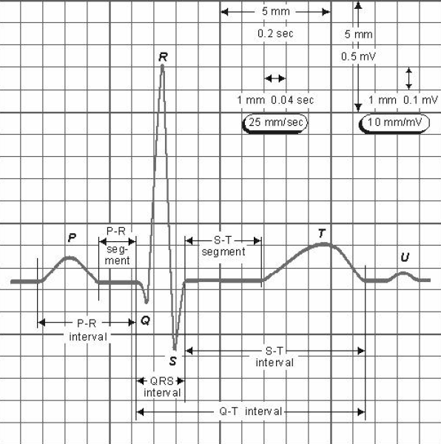

**(Fig-1.2-Insight of ECG )**

**Characteristics of ECG**

1. **P Wave**

1. The amplitude should not more than 3 mm tall.

2. The peak of the P wave should be smooth and rounded.

3. The P wave deflects in positive direction in 1,11 and aVF leads

1. **PR Interval**

1. Measure from the beginning of the P wave to the beginning of the QRS complex.

2. The normal PR interval duration is 0.12 to 0.20 seconds or 120–200 ms.

1. **QRS Complex**

1. The wave of ventricular depolarization - QRS complex, even if not all of the components (the Q, the R, and the S) are present.

2. Q wave: the first downward stroke.

3. R wave: the first positive stroke

4. S wave: a negative stroke that follows a positive upstroke.

5. The width of the QRS is measured from the beginning of the

Q wave to the end of the S.

1. **ST Segment**

1. Begins at the J point (the point at which the QRS complex ends and the ST segment begins).

2. Indicate the period of time between the end of ventricular depolarization and the beginning of ventricular repolarization.

3. Generally the ST segment is isoelectric, or on the baseline.

1. **T Wave**

1. The wave of ventricular repolarization.

2. The period from the beginning of the T wave to nearly the end is called the “relative refractory period”. At this time, the ventricles are vulnerable. A stronger than-normal stimulus could trigger depolarization.

3. Usually deflects in the same direction as the QRS complex, and should be smooth and rounded.

1. **The baseline (isoelectric line)**

1. The resting phase of the conduction cycle, or the polarized state.

2. The straight line on the ECG tracing, represents an absence of electrical activity.

3. Important because the beginning of a waveform is marked by a departure (or movement away) from the baseline

4. The ending of a waveform is marked in terms of a return to the baseline. This is critical to understand because in order to be able to examine and measure a waveform, a clear understanding of where the waveform begins and ends is necessary.

5. The baseline is the reference point for determining the beginning and end of a waveform.

**SYNCHRONIZED AVERAGING FILTER:**

Linear filters fail to perform well or are not applicable when the signal and noise spectra overlap. Synchronized signal averaging can separate a repetitive signal from noise without distorting the signal.

If the noise is random after adding the signal with its own signal the noise of the signal will become zero. After adding the signal divide the signal M(total number of times

added). So that the magnitude of the signal will match the original signal.

𝑚

𝑔(𝑛) =Σ (𝑠(𝑛) + 𝑁(𝑛)

𝑛=1

s(n)=sampled main signal (PQRST part of ecg) & N(n)=noise signal

By adding it for m times N(n)=0,s(n)=ms(n).

So g(n)=ms(n).

s(n)=g(n)/m.

**Methodology**

**1. Data Acquisition:**

- Raw ECG data will be acquired from standard databases such as PhysioNet or recorded using ECG recording devices in a controlled clinical environment.

- Ensure that the acquired data is of high quality, free from artifacts, and recorded at an adequate sampling rate to capture the necessary signal details accurately.

**2. Preprocessing:**

**1. Noise Removal:**

- High-pass and low-pass filters will be applied to remove baseline wander and high-frequency noise, respectively. High-pass filters attenuate low-frequency components, effectively removing baseline wander, while low-pass filters eliminate high-frequency noise, such as muscle artifacts or electromagnetic interference.

**2. Artifact Removal:**

- Adaptive filtering techniques, such as adaptive noise cancellation or adaptive line enhancers, will be employed to suppress motion artifacts and other interference.

- Adaptive filters dynamically adjust their coefficients to adapt to changing signal conditions, making them effective in removing non-stationary artifacts.

**3. Signal Enhancement:**

**1. Feature Preservation:**

- Filter parameters will be optimized to preserve important ECG features, such as QRS complexes and ST segments. QRS detection algorithms may be employed to identify and analyze QRS complexes before and after filtering to ensure preservation of these critical features.

- Optimization techniques, such as grid search or genetic algorithms, may be used to find the optimal filter parameters that maximize feature preservation.

**2. Signal Smoothing**:

- Savitzky–Golay filtering, a type of polynomial smoothing filter, or similar techniques will be applied to smooth the signal while retaining its essential characteristics. These smoothing filters effectively reduce noise and variations in the signal without significantly distorting the underlying features. The degree of smoothing will be adjusted based on the level of noise and the desired balance between noise reduction and feature preservation.

**4. Implementation in MATLAB:**

-The entire signal processing pipeline will be implemented using MATLAB, leveraging its powerful signal processing toolbox and libraries. MATLAB scripts or functions will be developed to automate the processing pipeline, allowing for efficient and reproducible data analysis.MATLAB's interactive development environment facilitates rapid prototyping, debugging, and optimization of signal processing algorithms, accelerating the development process.

**Initial ECG Signal Code (Before Filtering)**

ecg = load('ecg_data.dat');

fs = 1000; % Sampling rate in Hz

t = (0:length(ecg)-1)/fs;

N=length(ecg);

plot(t, ecg);

maxi=max(ecg);

xlabel('Time (s)');

ylabel('ECG signal (mV)');

title('Sample ECG Cycle');

out=zeros(1,788);

for i=1:788

out(i)=ecg(i);

end

plot(out);

count=0;

posi=zeros(1,N);ind=1;

cross_function=xcorr(out,ecg);

maxi_cor=max(cross_function);

for i=1:length(cross_function)

if(cross_function(i)>0.75*maxi_cor)

posi(ind)=i;ind=ind+1;%saving the position of in array

if(i+788<=N-1)

for k=1:788

out(k)=out(k)+ecg(i+k); %adding the selected signal with samples

signal

end

count=count+1; % update the count after adding the signal

end

end

end

plot(out);

for i=1:788

out(i)=out(i)/(count+1);

end

plot(out);

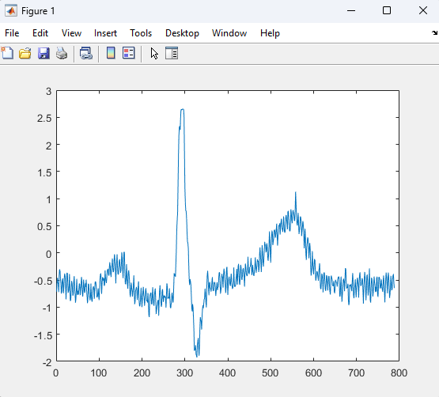

**(Fig-1.3-Insight of ECG signal before filtering)**

**ECG Signal Code (After Filtering)**

% Load ECG data from a file

ecg = load('ecg_data.dat');

% Sampling rate in Hz

fs = 1000;

% Time vector based on the sampling rate and length of the ECG data

t = (0:length(ecg)-1)/fs;

% Number of samples in the ECG signal

N = length(ecg);

% Plot the original ECG signal over time

plot(t, ecg);

% Find the maximum value in the ECG signal

maxi = max(ecg);

% Label the axes and title the plot

xlabel('Time (s)');

ylabel('ECG signal (mV)');

title('Sample ECG Cycle');

% Initialize an output array with zeros

out = zeros(1, 788);

% Copy the first 788 samples from the original ECG signal to 'out'

for i = 1:788

out(i) = ecg(i);

end

% Plot the first 788 samples of the ECG signal

plot(out);

% Initialize variables for counting and storing positions

count = 0;

posi = zeros(1, N);

ind = 1;

% Compute the cross-correlation between 'out' and the original ECG signal

cross_function = xcorr(out, ecg);

% Find the maximum value in the cross-correlation function

maxi_cor = max(cross_function);

% Loop through the cross-correlation function

for i = 1:length(cross_function)

% Check if the cross-correlation value is above 75% of the maximum

if cross_function(i) > 0.75 * maxi_cor

% Save the position in the 'posi' array

posi(ind) = i;

ind = ind + 1;

% If there are enough samples left in the ECG signal, add them to 'out'

if i + 788 <= N-1

for k = 1:788

% Add the selected signal with samples

out(k) = out(k) + ecg(i+k);

end

% Update the count after adding the signal

count = count + 1;

end

end

end

% Plot 'out' after adding signals

plot(out);

% Normalize 'out' by dividing by (count + 1)

for i = 1:788

out(i) = out(i) / (count + 1);

end

% Plot the final 'out' after normalization

plot(out);

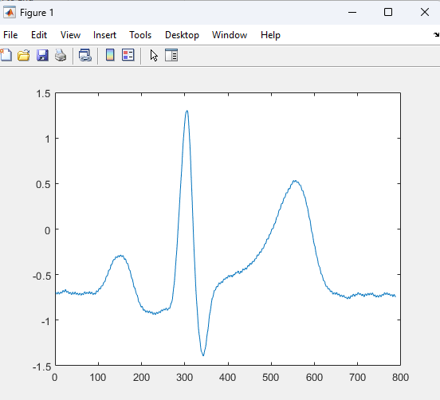

**(Fig-1.3-Insight of ECG signal after filtering)**

**Conclusion**

In this project, we have developed a comprehensive approach for transforming raw ECG data into enhanced signals suitable for accurate interpretation. By applying advanced filtering techniques implemented in MATLAB, we have effectively removed noise, artifacts, and baseline wander while preserving important ECG features. The results demonstrate significant improvement in signal quality, paving the way for more accurate diagnosis and analysis of cardiac abnormalities. Future work may involve further optimization of filtering algorithms and validation on diverse datasets to enhance robustness and applicability in clinical settings.

**Precautions**

1. **Data Quality**: Ensure the raw ECG data used for filtering are of high quality, free from artifacts or corruption.
2. **Filter Selection**: Carefully select filtering techniques based on the characteristics of the ECG signal and specific noise sources.
3. **Parameter Tuning**: Properly tune filter parameters to balance noise reduction with preservation of important signal features.
4. **Validation**: Validate the filtering approach using diverse datasets and expert annotations to ensure generalizability and accuracy.
5. **Real-time Processing**:Consider computational resources and algorithm efficiency for real-time applications, optimizing where necessary.

**Further Scope**

1. **Integration with Machine Learning Techniques:**

1. By combining advanced filtering with machine learning models, the accuracy and efficiency of cardiac abnormality detection can be further enhanced.

1. **User-friendly Interface and Deployment:**

1. Develop a user-friendly interface for the MATLAB-based filtering pipeline, making it accessible to healthcare professionals with varying levels of technical expertise.

1. **Exploration of Alternative Signal Processing Techniques**:

1. Explore alternative signal processing techniques beyond those implemented in MATLAB, such as deep learning-based methods or non-linear filtering approaches.

1. **Standardization and Interoperability:**

1. Contribute to the standardization of ECG signal processing techniques and data formats to ensure interoperability and compatibility with existing healthcare systems and electronic health records (EHRs).

1. **Adaptive Filtering Algorithms:**

1. Investigate the development of adaptive filtering algorithms that can dynamically adjust filter parameters based on the characteristics of the input signal.